Lab 6

Get Voc’

Tweak Resistance to get Voc/2 and the resistance would be equal to Rth

1) Show the mathematical derivation for how we know the voltage at two nodes will be Voc/2when a resistor, Rload, is connected to those nodes that is equal to RTh. Hint: Begin by drawing the generic Thevenin Equivalent Circuit with Rload attached to the two nodes(similar to Figure 3)and write out the voltage divider equation.

2) Measure and record the resistance between pin1-pin2 and between pin2-pin3 of your variable resistor. What value do these sum to? Measure the resistance between pin1-pin3to check (this value should be close to the previous summation). Individuals’ pin1-pin2 andpin2-pin3 resistance measurements will vary depending on where your wiper happens to be currently set. (Everyone’s summation should be close to 10kΩ, though.)

2. data

* + Pin 1 & 2 resistance 2.025 kOhm
  + Pin 2 & 3 resistance 8.0577 kOhm
  + Pin 1 & 3 resistance 9.8577
  + Sum of 1&2 and 2&3 = 10.0877

3. data

* Vs = 15.656v

**Data for box 1**

* Voc = 5.2121v
* V0c/2 = 2.605v
* Voc/2 mesured = 3.6045
* Voltage drop from b1-b2 =
* Rth = 5.3194 kOhms

**Data for box 2**

* Voc = 15.617
* Voc/2 = 7.8085
* Voc/2 mesured = 7.8001
* Rth = 1.9938 kOhms

**Data for box 3**

* Voc = -3.1239
* Voc/2 = -1.56195
* Voc-2 measured = -1.5632
* Rth = 1.204 kOhms

4.

**Open box 1**

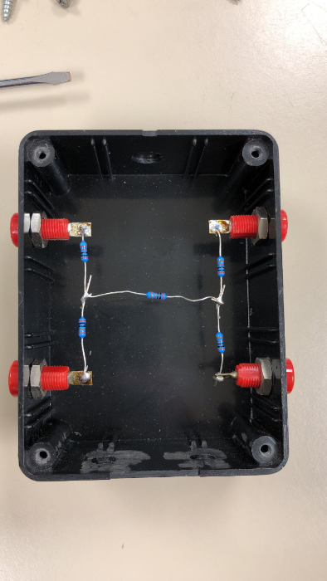

**Color code for resistors**



**Open box 2**

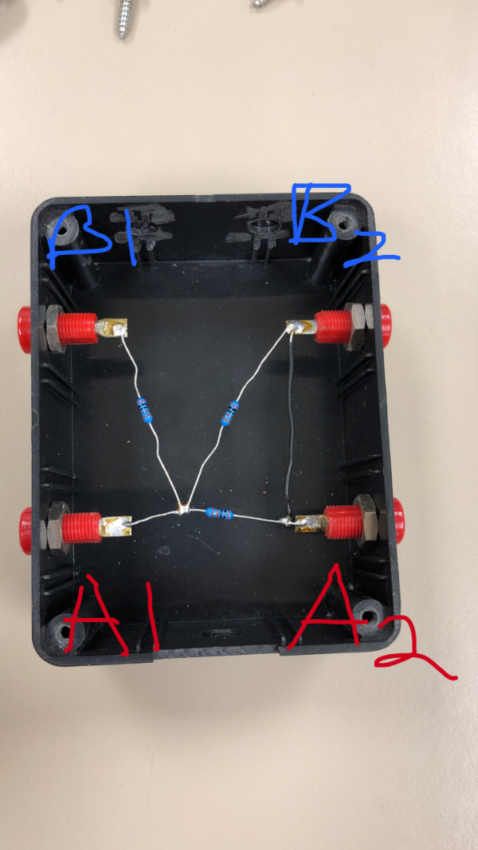

Open Box 3

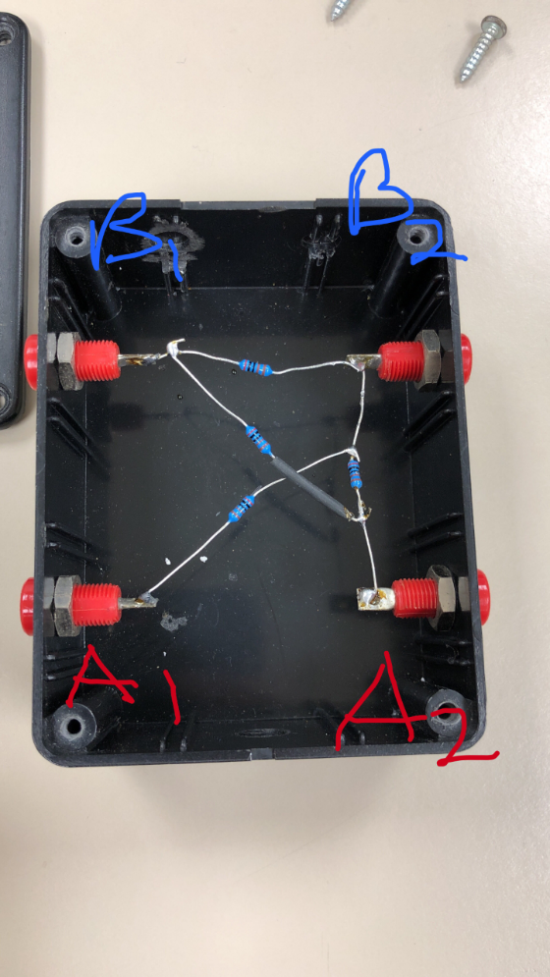

5). Now knowing what you do about this specific black box, is it possible to measure theThevenin resistance at B1-B2 directly from the black box? If so, explain how you would doit? If not, why not? Hint: keep in mind that you have access to the only power supply“in”the black box (Vs connected at A1-A2).